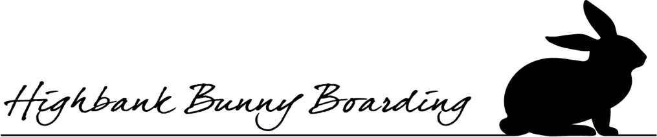
Rabbits Checklist (please fill one form per Rabbit)
Name of Guest
D.O.B
Gender
Proof of 2 upto date Vaccinations are required (pls send images on whats app when booking as well as bringing originals on arrival)
Combination Myxo/RVHD1 Vaccine Date
RVHD2 Date
Date of Neutering (please see terms and conditions). Date
Medical History and Special Requirements
Whilst your bunnies are in my care I would be grateful if you would inform me of any previous medical History your bunnies have encountered in the past.
Has your Rabbit had fly Strike?
Does your Rabbit regularly have a dirty Bum?
Has your rabbit ever experienced head tilting syndrome (Torticollios)
Does your rabbit have any Dental Disorders?
If there is any additional information you would like to provide that would help to your bunny enjoy their stays at Highbank Rabbit Boarding please write in the box below. If you could describe your bunny’s temperament and also likes and dislikes.

Medical Treatment
Please list any ongoing medication that will need to be administered throughout the day(pls refer to terms and conditions)

When will this be needed to be administered?

Enrichment
Please list any items that you may wish to bring to ensure your rabbit has any enjoyable stay with us

Please state if your bunny prefers a water bottle or water bowl

Do they use a corner or rectangle litter tray?

During your bunnies stay I like to take lots of photos of our boarder that I use on Highbank social media pages and sometime use photos for Highbank Bunny Boarding web page. If you do not wish me to use your bunnies picture please let me know.

Daily Feeding Routine
Greens
How many Greens and Herbs are given per day

Likes and Disliked greens

Pellet Food (if you forget your bunnies pellet food I will ask for an upfront payment of £6 or you can collect it yourself as pets at home is a 5 min drive away from Highbank.
Please state the Brand and exactly how much pellet feed your bunnies eat in a day

Declaration of using your bunnies’ images during their stay
During your bunnies stay I like to take lots of photos of our boarder that I use on Highbank social media pages and sometime use photos for Highbank Bunny Boarding web page. If you do not wish me to use your bunnies’ picture, please let me know.

I confirm that I have read and agree by the Terms Conditions set by Highbank Bunny Boarding.
Signature: Date:

Highbank Bunny Boarding, Highbank, Newton Road, Sudbury, co10 2rs. Tel 07949 240780

